**APPLICATION FORM AND INFORMATION**

ZAMCOACH360, ICCE COACH DEVELOPER TRAINING

Cohosted by Zambia and Zimbabwe, 2024-2025

***“COACH DEVELOPERS develop, support and challenge coaches to improve their knowledge and skills to provide positive and effective sport experiences for all participants.”***

(International Coach Developer Framework, ICCE, 2014)

***Please complete the attached application form, profile and CD self-assessment to successfully apply for the training!***

The National Olympic Committee of Zambia (NOCZ) in collaboration with Zimbabwe Olympic Committee (ZOC) with support from the Norwegian Olympic and Paralympic Committee and Confederation of Sport (NIF) work to improve the quality and recognition of coaches at all levels in Malawi, Zambia and Zimbabwe are proud to invite you to apply to this Coach Developer Training programme cohosted by Zambia and Zimbabwe.

The training is specifically designed for the people from National Sport Associations that are assigned and work to train and support coaches’ development who can be a technical director or an experienced coach staff. In order for you to be able to fully participate, share and maximize the participation in this training, it is expected that you have some formal training and experience in coach development.

**Outcomes of the training:**

The persons that participate will qualify as ICCE trained facilitators and should by the end of the training be:

* familiar with the Coach Developer concept
* be able to apply different coach learning principles
* be able to facilitate theoretical and practical sessions using core principles of learning
* be able to assess and support coaches in the field

**Dates and timelines**

* Application opens on ***Friday 23rd August*** and Closes on ***Friday 30th August 2024***
* September 2nd – Announcement of Successful candidates
* October 7th – 12th 2024 Phase 1 of Workshop - Lusaka, Zambia
* November 2024 – February 2025 Practical work in home organization (Coach training, or field observation and coach review).
* December 2024 – Post training Catch up Webinar
* January 2025 Post Training Field Assessment – Phase 1
* February 2025 Webinar/Online Session: Introduction to Phase 2
* March 16th -22nd 2025 Phase 2 of the Training – Harare Zimbabwe
* June 2025 - Post Training Field Assessment – Phase 1

An CD self-assessment form is attached as part of this application, that you are expected to complete. This is an important part of your ability to reflect on strengths and areas of improvement as a CD.

In addition to the application below. Please send:

* a short CV/profile
* Copy of your passport
* a brief endorsement letter from your National Sport Association/Federation indicating that the applicant is attached to a national team (Minimum u17).

**Please send the completed application to:**

Zambian Applicants send to [admin@nocz.org](mailto:admin@nocz.org)

Zimbabwean Applicants to [programs@zoc.co.zw](mailto:programs@zoc.co.zw)

**by Friday 30th August 2024**

**Fees**

The Following application fees must be paid:

* Zambia - K500 for Female applicants and K750 for Male applicants to be paid via mobile money to +260974021232 (Felix Munyika-Reference should be ZAMCOACH360) or in Cash.
* Zimbabwe - $20 for Female applicants and $30 for Male applicants to be paid in Cast to ZOC

***\*Females are strongly encouraged to apply.***

***\*Kindly note that receipts will be issued upon payment in both countries***.

**Costs**

The expenses for the trainings are fully covered by the organizers. This includes:

* Local transport to venue
* Accommodation
* Meals for the days of the training
* Training venue and course materials

Thanks!

*From the Training Coordinating Team*

**APPLICANT PROFILE**

Picture

**PERSONAL DETAILS**

**Full Name**

Prefix First Name Middle Name Last Name

  

**Current Address**

**Gender**

**Nationality**

**Date of Birth:**

Month Day Year

**Email Address:** ex: myname@example.com

**Phone Number**

**Current Employer Organization Job Title**

**EDUCATION**

**Highest Academic Qualification Institution**

**Coaching Education Qualification Institution**

**List any formal coach developer/tutor/learning facilitator training**

**How many coaching courses or programmes have you delivered in the past 24-months?**

**Have you assessed any coaches in the past 24 months?**

(circle the answer below).

Yes No

**Any other information you feel is important to share:**

**SELF-ASSESSMENT OF ME AS COACH DEVELOPER**

This self-assessment aims to create awareness through self-reflection on your personal development as a coach developer. This will help you grow as a CD, and be better equipped to support coaches in their development path.

The assessment has three parts where you are asked to answer some basic questions about yourself.

1. What qualities do I possess that made my organisation chose me to work as a coach developer?
2. How do I want to be viewed as a coach developer in the future?
3. What do I want to prioritize in my work in order to become this coach developer?

Select 1-3 areas (competencies and behaviors) that you want to challenge yourself in, and to develop to become an even better CD.

This is the begging of a simple personal development plan as CD. The self-assessment will build the foundation for the work we are continuing during the face to face training. Here we will work to further the areas you have chosen.

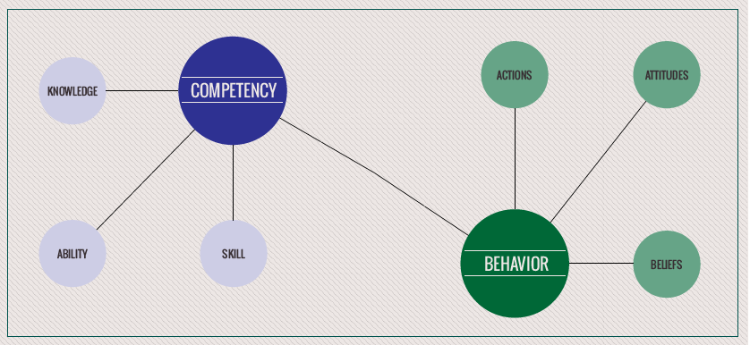

*Competency – be able to do, practical (skills, attitudes, and behaviours)

*knowledge – Know something, be able to explain, theoretical  
  
**Prioritized development areas:**Based on your assessment and desired, what concrete areas do you want to work on? (max 3)

1. _______________________________________________

2. ________________________________________________

3. ________________________________________________